NEWSLETTER
March 2024

Chief Executive Update
Hello and welcome to our Spring Newsletter. It has been a busy start to 2024, time is flying already. We are progressing with the move to our new Sensory Hub in Perth. I am hoping that the hub will be open by the end of May and we will share further news before then about the new location. We will be planning a launch event and details will follow nearer the time.

We will be planning activities and group sessions starting in the summer and we would be keen to hear from you about what activities you would like us to offer.

We also have social groups available in the wider community and we are currently looking for volunteers to provide support for a couple of hours per week. If you would like to find out more, please contact us.

We had STV filming at the High Street Sensory Hub in February you can watch the clip on https://news.stv.tv/v/sight-and-hearing-loss-charity-sees-donations-drop

Thank you for your continued support, we cannot achieve all that we do without our volunteers and donations. If you would like to raise much needed funds for VisionPK please do contact us.

Have a wonderful Springtime! - Kate Charles, CEO
VisionPK Activities at the AK Bell Library in Perth:

Tues 05 March 1pm to 2.15pm – Harbours and communities of the Tidal Tay. Guest speaker: VisionPK Volunteer Anthony.

Tues 12 March 1pm to 2.15pm – Social Café and Dominoes Club.

Tues 19 March 1pm to 2.15pm – Social Café. Details to be confirmed.

Wed 27 March 10.30am – Woodland walk at Kinnoull Hill Jubilee Trail (wide, firm and smooth track) followed by tea/coffee and a chat. Accessible toilets available. Please let us know if you’d like to join.

Tues 16 April 1pm to 2.15pm - Social Café. Details to be confirmed.

Tues 30 April 1pm to 2.15pm - Social Café. Details to be confirmed.

Tues 14 May 1pm – Guided tour of local History Centre and Archive. Places are limited so make sure to let us know if you’d like to come along!

We would love to know if there would be any interest in joining any outdoor activities or the poetry and history group with guest speakers from U3A.

If you’d be interested in coming along to any of the above activities or would like some more information, please contact Monika by calling 01738 626969 or email info@visionpk.org.uk

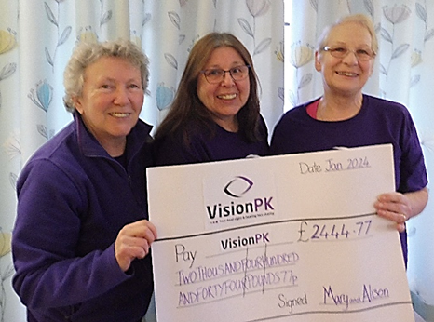
Fundraising Ambassadors Fly High! Alison Henry and Mary Gavin, from Comrie, presented a cheque for £2,444.77 to VisionPK. The two women completed a nerve-racking sky dive challenge to raise much needed funds to help with VisionPK’s Sensory Hub development.
Our community development worker, Lidia Dye, was happy to accept the cheque on behalf of VisionPK and said, “It is great when community members support our work, Mary and Alison have been wonderful, we thank them and value their support and contribution.”
Pictured: Lidia Dye, Mary Gavin and Alison Hendry

Drop in Sessions
Remember VisionPK has drop in sessions every week when a member of the Client Services Team is available at the times noted below to support clients, members of the public and health and social care professionals. Staff can offer information, advice, practical support and time to talk. No appointment is necessary, but you may be asked to wait if the staff member is occupied.

Monday’s 1.30pm – 4.00pm Sight Loss
Wednesday’s 1.30pm – 4.00pm Sight Loss
Friday’s 1.30pm – 4.00pm Hearing Loss

Volunteer and Help Us Fundraise for VisionPK
At VisionPK, we are reaching out to you and your family and friends in the community, to invite you to become a vital part of our mission by volunteering with our Fundraising team.
VisionPK is committed to empowering individuals with visual impairments to lead independent and fulfilling lives. However, we cannot achieve these goals without the support of passionate and dedicated volunteers.
Whether you have prior experience in fundraising or are new to the world of charitable work, your commitment can make a meaningful impact. It’s also rewarding and fun!
You can get involved with Event Planning, Awareness Sessions, Community Outreach and Administration
Joining VisionPK's Fundraising Team is not just an opportunity to give back, but also a chance to be part of a supportive community working towards a common goal. Your contributions, big or small, can make a lasting difference in the lives of those with sensory impairments.
For more information and an informal chat please contact our Fundraising Manager, Wendy Stenberg on 01738 626969 or wendy.stenberg@visionpk.org.uk. Thank you.
If you want to stop receiving our newsletter or want to receive it by email, please contact us using the methods below.
 | 01738 626969 |  | info@visionpk.org.uk |  | www.visionpk.org.uk
 | /visionpk2 |  | @visionPK2

